Chapter 2 Test Review ITA NAME: ____________________________________
Define: Know the definitions of…
1. Coefficient 3. Equation 5. Open sentence 7. Term
2. Constant 4. Like terms 6. Solution
Properties:
8. Associative properties of addition and multiplication deal with a change in _Grouping_________.
9. Commutative properties of addition and multiplication deal with a change in _Order .
10. Identity element of addition is _0_.
11. Identity element of multiplication is __1_.

Name the properties.

12. 13. $3⋅1=3$ 14. $9=0+9$ 15. Commutative Identity for x Identity for + Associative

In the expression :
16. The coefficients are? 4,3,-2,1 17. There are how many terms? 5
18. The constants are? -7 19. The variables are? x,y

Simplify the following.

20. 21. 22.
$−4n+\text{10}$ $\text{12}k+\text{18}$ $3h−9k$
23. 24. 25.
$−\text{12}m+\text{21}$ $−\text{15}x−\text{27}$ $\text{11}y+6$
Solve the following equations algebraically:

26. 27. 28. 29.

$h=−\text{23}$ $k=3$ $n=−\text{13}$ $m=\text{20}$

30. 31. 32. 33.

$u=−6$ $v=−\text{63}$ $w=3$ $x=−\text{128}$

Solve the following inequalities. Also GRAPH

34. 35. 36.
$y<−5$ $z≥\text{29}$ $−1≤h$ or $h≥−1$

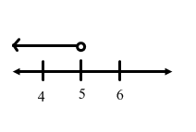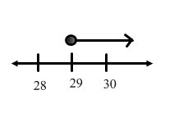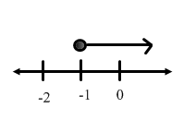

37. 38. 39. 40.
$m<−5$ $n≤−\text{72}$ $u≤−3$ $v<\text{100}$

